1.13: a) 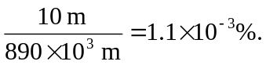

b) Since the distance was given as 890 km, the total distance should be 890,000 meters.
To report the total distance as 890,010 meters, the distance should be given as 890.01 km.

